Assignment: 1 Linux Commands

Title
Linux Basic Commands: File and Directory Management, Viewing Files, Pattern Searching, Compression, Downloading Files, Permissions, and Environment Variables.

Objective
To learn and practice basic Linux commands for:
- Creating and managing files and directories
- Viewing file contents
- Searching patterns in files
- Compressing and extracting files
- Downloading files from the internet
- Changing file permissions
- Working with environment variables

Commands Used and Explanation

1. Creating and Renaming Files/Directories
Create Directory

Command:
mkdir test_dir
Explanation:
Creates a new directory named test_dir.

Create Empty File
Command:
touch example.txt
Explanation:
Creates an empty file named example.txt.

Rename File
Command:
mv example.txt renamed_example.txt
Explanation:
Renames example.txt to renamed_example.txt.

Output

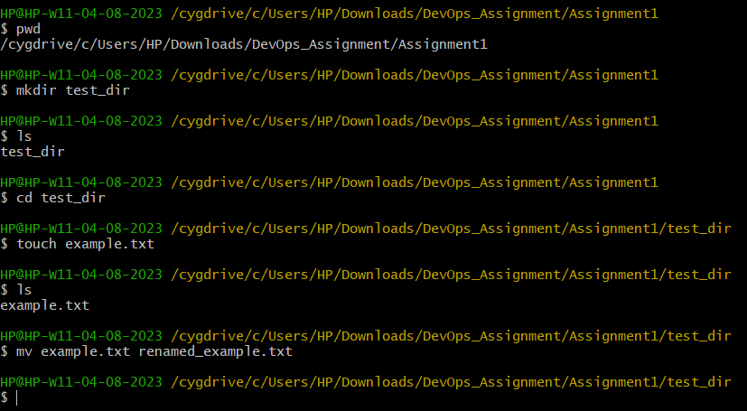

2. Viewing File Contents
Display Complete File

Command:
cat /etc/passwd
Explanation:
Displays the entire contents of the /etc/passwd file.

Display First 5 Lines
Command:
head -5 /etc/passwd
Explanation:
Shows the first five lines of the file.

Display Last 5 Lines
Command:
tail -5 /etc/passwd
Explanation:
Shows the last five lines of the file.

Output
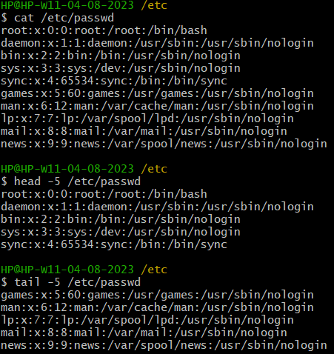

3. Searching for Patterns
Search for "root"

Command:
grep root /etc/passwd
Explanation:
Searches and displays all lines containing the word root.

Output
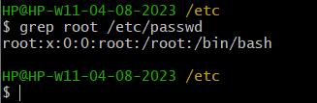

4. Zipping and Unzipping
Compress Directory

Command:
zip -r test_dir.zip test_dir
Explanation:
Compresses the directory test_dir into a ZIP file named test_dir.zip.

Extract ZIP File
Command:
unzip test_dir.zip -d unzipped_dir
Explanation:
Extracts the ZIP file into a directory named unzipped_dir.

Output
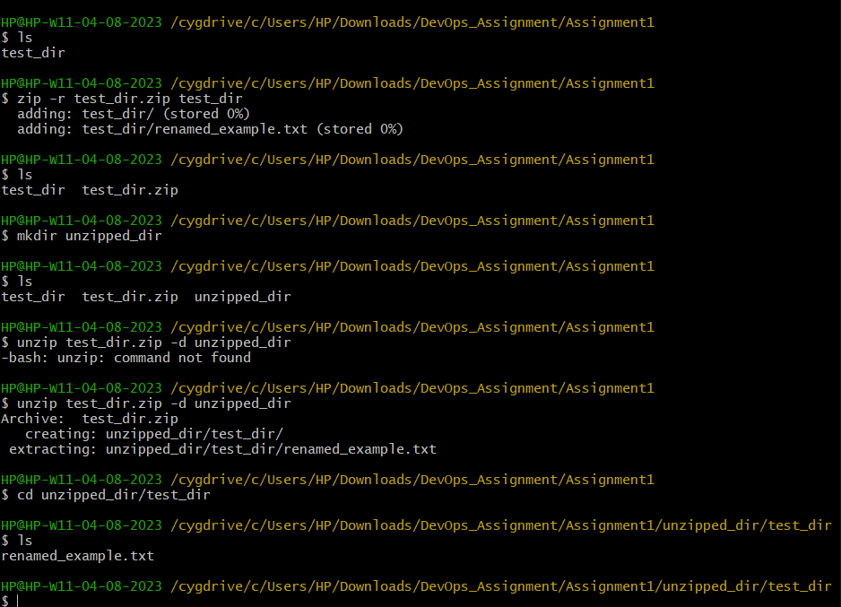

5. Downloading Files

Command:
wget https://example.com
Explanation:
Downloads data from the specified URL and saves it locally.

Output
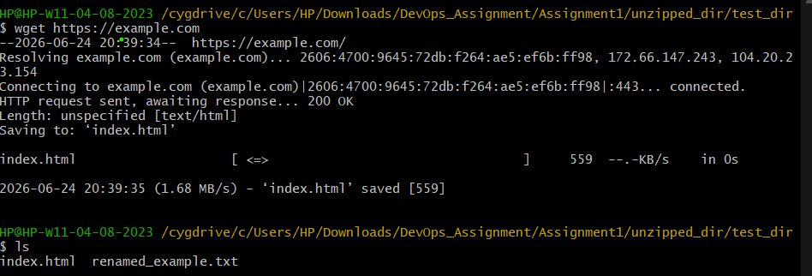

6. Changing Permissions

Create File
Command:
touch secure.txt

Make File Read-Only
Command:
chmod 444 secure.txt
Explanation:
Changes file permissions so everyone can only read the file.

Verify Permissions
Command:
ls -l secure.txt

Output
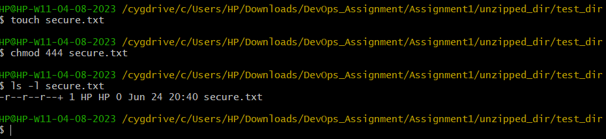

7. Working with Environment Variables

Create Environment Variable
Command:
export MY_VAR="Hello, Linux!"
Explanation:
Creates an environment variable named MY_VAR.

Display Environment Variable
Command:
echo $MY_VAR
Output:
Hello, Linux!

Output
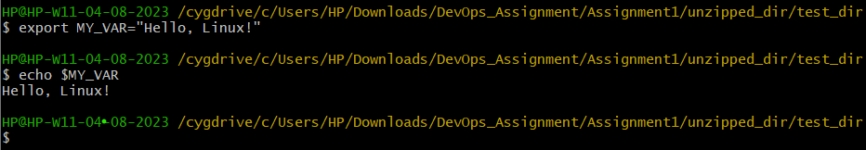

Conclusion
The Linux commands for file and directory management, viewing file contents, pattern searching, file compression and extraction, downloading files, changing permissions, and managing environment variables were successfully executed and verified. The practical helped in understanding the basic Linux command-line environment and system administration tasks.
GitHub Repository:
https://github.com/sushilkumar121225/devops-assignments

